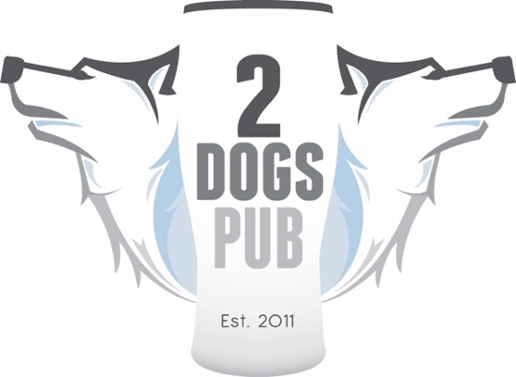

COME SUPPORT

BRAIN INJURY ALLIANCE OF IOWA
AT 2DOGS PUB!!

SATURDAY, OCTOBER 20
8AM TO MIDNIGHT
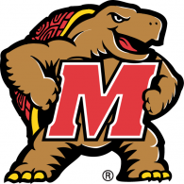
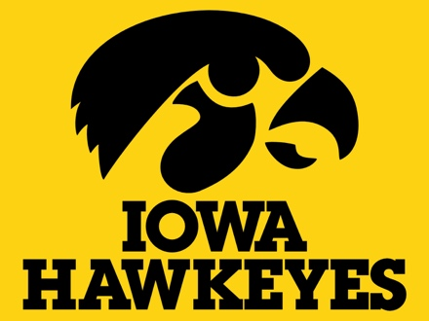
VS

HOMECOMING GAME KICK OFF AT 11:00AM!

Sales from 8am until 3pm count DOUBLE toward the total sales!!

Take advantage of the entire day, 8-11am breakfast, and regular menu until close! Alcohol sales are also included! The more you participate, the more 2 Dogs Pub will donate. 10% of sales between 0-$399, 15% $400-$999 and 20% over $1,000 in sales.

